BFCACT

Foster Procedures
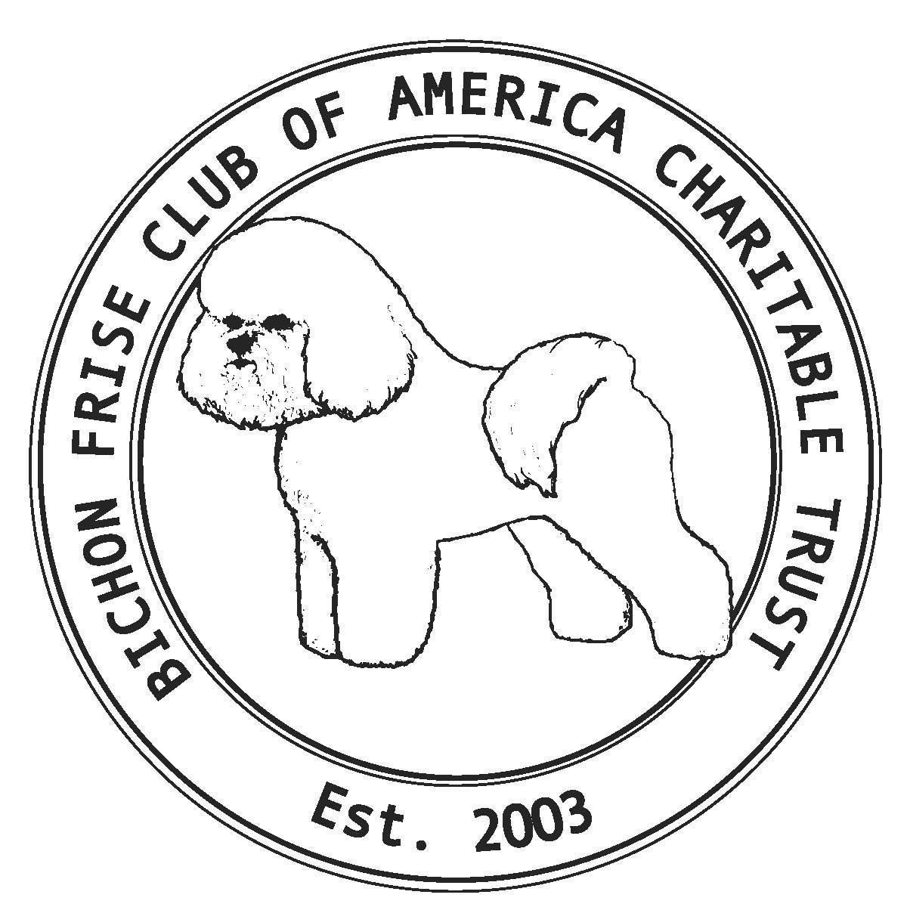

Contents
Version Control 2
Message from the Chair 3
Our Board of Directors 3
Our Rescue Contact Information 3
Bichon Intake Process 4
Vetting The Dog 4
Emergencies 5
Payment for Expenses 5
Record Keeping 6
Weekly Updates 6
Interviewing Potential Adopters 6
In Person and Home Visits 8
Final Adoption 8
Post Adoption 9
Permanent Fosters 9
Recognizing our Fosters 9
Appendix 10

Version Control
Version # | Date | Change Description | Approver
V 1.0 | Feb 1 2024 | Initial Publication | Z Kern

Message from the Chair
Our Rescue could not survive without our fosters. You play an essential part in our efforts to help dogs in need. With your care and love, we are able to place surrendered or abandoned Bichons in loving homes, some of whom would not have been adoptable without you. You help us develop and nurture relationships across the country that help us expand our visibility and re-inforce our strong reputation in the community and enable us to raise funds for the medical rehabilitation of our Bichons. You maintain financial records that are critical to us complying with the IRS regulations involved with a 501(c)(3) charity. You are the backbone of our 100% volunteer team
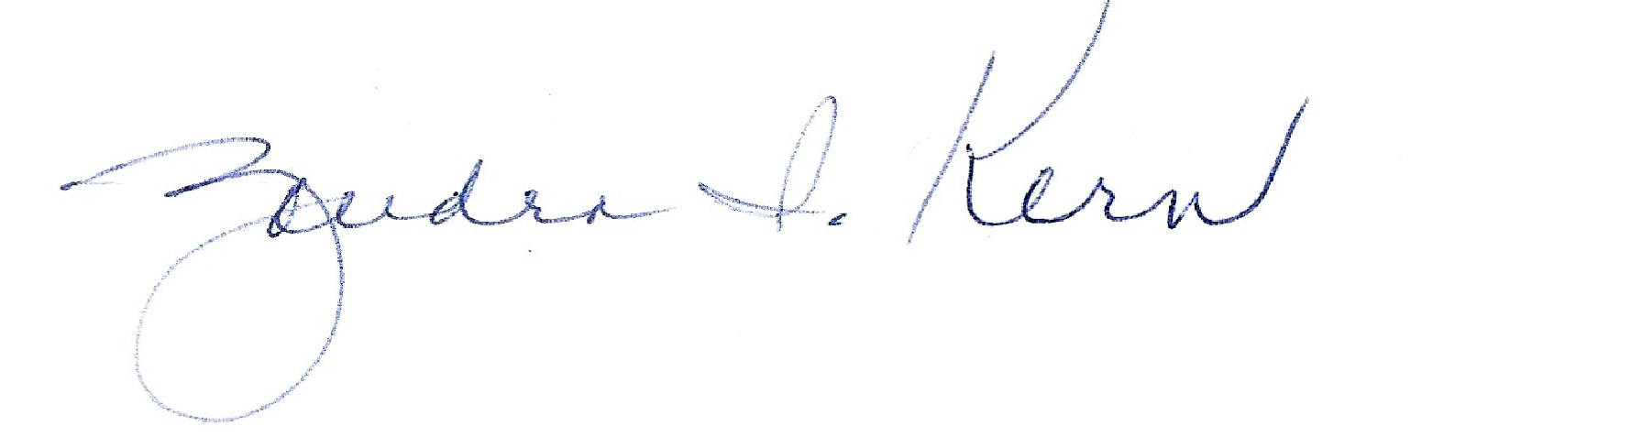
Zandra Kern
BFCACT Chair

Our Board of Directors
Name | Role | Email | Cell
Zandra Kern | Chair, Trustee and Intake Coordinator | zikern@verizon.net | 703-401-9551
Gail Antetomaso | Trustee | gailofgaylor@gmail.com | 516-524-5546
Karren Snell | Trustee and Accountant | klsnell@live.com | 260-433-1318
Charmaine Mortley-Wood | IT Support | charmaine.mortleywood@gmail.com | 703-200-5528
Susan Payne | Communications | susanhpayne@cs.com | 703-201-8978
Romy Jaffe | Adoption Coordinator | rejaffe@hotmail.com | 703-629-7837

Our Rescue Contact Information
Phone & Fax 866-473-0722
Website: www.bichonrescue.org
Email: mailto:bfcact-board@googlegroups.com
Facebook.com/BFCACT

Bichon Intake Process
The Intake Coordinator is responsible for the intake of rescue Bichons. No Bichons can be brought in without their knowledge and approval. The Intake Coordinator is responsible for coordinating that BFCACT has the authorized paperwork to accept any dog into rescue.
As a foster, you will be contacted about your availability. If you agree to foster a specific dog, you will be provided with all veterinarian records and/or other information about your rescue. Initial vetting instructions will also be provided based on the information received. You may be asked to follow-up with the previous owner and/or the veterinarian to obtain additional records. Covered expenses for your foster dog will be discussed with you at the time of foster placement.
If picking up a dog or dogs from owners, suggest meeting in a neutral location. Ask for dog food for the transition, medical records and rabies tags, and any information about the dog’s personality, routine, and likes/dislikes that will help you to care for the dog during this emotional and stressful time. Remember that the Bichon does not know you, so it is best to have the previous caretaker turn over the leash to the foster who can then walk the dog away while the owner departs.
Do not rename the dog. Only adopters should rename the dog as multiple name changes can be confusing to the dogs and complicate our ability to track them.
Fosters are asked to provide the Bichons with food, leash, collar and harness. The collar, leash and harness do not need to be new, and they do not need to go with the Bichon when it is adopted. Rescue will pay for food prescribed by a veterinarian. Purchases for any other supplies must be pre-approved.
When a new dog comes in the Adoption Coordinator will arrange for shipment of a donated handmade blanket and belly bands/panties, if needed. A Bichon rescue tag with our phone number will also be provided for the foster’s collar. This is extremely important to attach when received to help if the dog accidentally escapes.
Please send one or more pictures of the dog (at least one of which clearly shows its face) to mailto:bfcact-board@googlegroups.com with a few facts about your foster dog so that we can get it posted on our website, Facebook, PetFinder, and e-mail newsletter, when appropriate. Good photos help find the perfect adopter and raise much needed donations for vetting, supplies, and medications.

Vetting The Dog
BFCACT makes all medical decisions for all Bichons in rescue until formally adopted.
You may use your own veterinarian, however you must provide the attached Vet Introduction letter prior to service.
Provide the vet with copies of any medical records that you received when you accepted the Bichon to foster. Ask them to add these to the file of the dog. The following routine procedures are preapproved:
- Physical
- Spay or Neuter
- Shots - Rabies and Distemper
- 1 month supply of Heartworm/flea & tick
- Microchips for dogs under 10, unless dog is noted as a runner

The following procedures may be approved by the Intake Coordinator after the initial Vet exam and written estimate from the vet has been provided to the Intake Coordinator:
- Bloodwork
- Heartworm test if dog has not been on heartworm medication
- Fecal including Giardia
- Deworming
- Urinalysis
- Bordetella
- Lyme
- Influenza
- Dental
- Surgery
- Other tests as recommended by Vet

Many vets get free samples from suppliers. Please ask your vet for these, especially items like the first dose of Flea/Heartworm.

Emergencies
Contact Intake Coordinator if you need to take your foster to an emergency vet. If you cannot reach the Intake Coordinator on the phone, leave a voicemail with the reason you are taking the dog to the veterinarian and immediately proceed to the vet. Do not let the dog linger in pain or sickness.

Payment for Expenses
The BFCACT credit card will be used to pay for all veterinarian and foster-care related charges. Have your vet phone Karren Snell (primary) or Zandra Kern (secondary) or Charmaine Mortley-Wood (tertiary) who will provide the payment. Please ask your vet to leave a message if the phone is not answered. The vet will receive a callback promptly. Have your vet email a copy of the itemized receipt to mailto:bfcact-board@googlegroups.com Ask the vet to include the Bichon’s name and your name as foster on the receipt.
If you pay for a pre-approved expense and want reimbursement, you must complete the Expense Report and submit it to the Accountant, within 10 days after the expense has been incurred. They will verify that amounts match the receipts and totals are correct. Reimbursement may be declined if prior approval was not obtained. Reimbursement will usually be made within 15 days.

Record Keeping
It is your responsibility to track all approved expenses paid by you and BFCACT for your foster and keep an electronic Record on each Bichon you foster. Your vet can provide a full detailed statement of all expenses when the adoption is scheduled, even if BFCACT directly paid the bills. You may take a picture of any Record and save that if you did not get an electronic copy and do not have the ability to scan documents. You do not need to track or report expenses that you personally made that were not approved by BFCACT.
Copies of all vet records, all bills, signed BFCACT Transfer to New Home and the BFCACT Adoption Info Sheet, and any other related documents or forms are legal records and must be maintained and submitted to mailto:bfcact-board@googlegroups.com at the completion of the foster term for IRS purposes.

Weekly Updates
A weekly update on your foster is required to be sent to the Adoption Coordinator before end of day Thursday each week to let us know the status of your foster. Do not wait to reach out to the Adoption Coordinator at any time if there are any concerns or items you need help with.

Interviewing Potential Adopters
The goal of rescue is to place our Bichons as quickly as possible in their forever homes. This is because it is in the best interest of the Bichon to bond with the permanent family, and it also reduces Bichon Rescue’s expenses which need to be directed to saving as many dogs as possible.
The Adoption Coordinator will work closely with you to determine when the dog is ready for adoption and will send pre-screened and approved applications to you based on your guidance. Please recommend the type of home you think would be best for the dog, such as a fenced yard, other dogs, no cats, no small children…whatever you think will help in the selection of the best applications in the geographic areas you want to consider.
Discuss the adoption donation with the Adoption Coordinator prior to contacting the family. Advise them of the donation in the first conversation so they have time to consider, or you can move on if it is more than they want to pay. Let them know that any funds given ABOVE the requested amount for adoption may be taken as a charitable deduction.
Contact the potential adopters by email or phone to coordinate an interview date and time that is convenient for everyone. When calling, please identify yourself as a foster with Bichon Frise Rescue. We strongly recommend using Google Meet, Zoom, or other video conference tools to do the initial interview. The Adoption Coordinator can help you with this if it is new to you. It is also recommended to interview one applicant at a time, so as not to get people’s hopes up.
Be sure to re-review the potential adopter application answers prior to the first meeting. Tell potential adopters about the dog you are fostering, and why you think their application looks like a good fit. Tell them about our rescue to demonstrate that we are a reputable organization. Tell them the pros, cons if any, and whatever background information you may have. Remind them that all of our rescues are vetted and up-to-date on all shots and vaccines (except as noted above) and offer to send all medical records for them to review prior to meeting the dog. Review the adoption guidelines with the applicant regarding our 30-day refund policy, any special agreements that will be in the adoption paperwork that have been pre-approved (refunds for spay/neuter, etc). Remind adoption applicants that the agreement states they will always return the dog back to Bichon Rescue at any time if things do not work out.
Remember that you are interviewing the potential adopter as the advocate of the Bichon. If you do not feel comfortable with the candidate, move on and request more applications from the Adoption Coordinator.
Possible interview questions:
- How do you plan to train the dog to the ways of your home, especially during the first few weeks?
- Discuss in detail where the dog will stay during the day and night and when the dog will be alone.
- Discuss how the dog will adjust to other people in the home, like children, visitors, or older family members who may find them a trip hazard.
- Ask what types of activities they plan to do with the dog to ensure it is a good fit for the energy level of the dog.
- Discuss standard grooming and vetting expenses for a typical bichon based on age and make sure they have planned appropriately.
- Discuss what they will do with the dog during extended trips away from home.
- Make sure they have a support system and discuss who will look after the dog if they are unavailable at any time.
If the conversation goes well and you think they would be great adopters, ask the potential adopter to let their vet and groomer know you will be calling as some want approval from the family before they will release information.
Possible Vet/Groomer questions:
- Was/Is the previous/current pet up to date on medical needs?
- When was the last time you saw their pet? How often do you see them?
- Are they current on all bills?
- Does their address match the one you have in the application?
- Do the dogs they say they have/had match the data on file with the vet records?
- Has there ever been a time when the staff had a bad interaction with the owners?
After you have completed the Vet/Groomer check, and you feel comfortable with moving forward, be sure to send a copy of all medical records to the potential adopter, along with the completed Transfer to New Home form so adopters can review it prior to the in person visit.

In Person and Home Visits
Make the first in person visit at your house, or a neutral setting like a park or pet store, with no expectation to turn over the foster dog. All family members and pets must meet the dog prior to placement. Make sure the potential adopter knows prior to the meeting that you are not committing to turn over the dog at the first in person meeting. Always remind people we adopt based on the best interest of all parties, not just because the adopter wants the dog. The meet and greet will give both you as the foster, and the potential adopter, time to decide if this Bichon is the right fit. There are several ways to approach this part of the process, and the Adoption Coordinator is a great resource for ideas.

A home visit is required to confirm an adopter is appropriate. If this is not possible, you may do a zoom visit and a virtual house tour. Look for whether the home looks safe, clean, dog friendly, and that there are no red flags. If you do a Zoom type visit, they must walk the camera around the whole house and yard. You may do a virtual home visit before the first in person meeting if convenient.

Final Adoption
If both you and your foster dog feel 100% comfortable after the in person meeting and after a physical or virtual home visit, you may finalize the adoption.

On the adoption day, bring all supplies the dog is used to that you are prepared to transfer including the dog’s rabies tag, the blanket you received, 1 panty or belly band if applicable, any remaining medication, and 3-4 days worth of food so they can transition to what they will feed the dog.

If the adopters have authorized us to publish a picture of them with their dog, take a photo on the adoption day of the adopters with the Bichon. This is critical to fundraising and must be sent to mailto:bfcact-board@googlegroups.com

You must collect a signed Transfer to New Home form. This is the contract and a formal record that must be retained by you, with an electronic copy submitted to BFCACT.

You must also confirm payment has been received before releasing the Bichon. People can pay through our website or by check to BFCACT. We do not accept cash. If a check is received it is to be made out to BFCACT and mailed to Karren Snell, 20 N Public Square, Angola, IN 46703 within 48 hours. Write the name of the dog being adopted on the memo line of the check. Check or on-line confirmation email for payment must be received by foster before the dog is turned over. If you accept a check, take a picture of it and mailto:bfcact-board@googlegroups.com with the picture.

Post Adoption
After the adoption, it is your responsibility to complete and submit the final electronic copy of the Adoption Information Sheet to mailto:bfcact-board@googlegroups.com
Stay in regular contact with the adopter over the first week or two and let them know that we love pictures! Remind adopters of the 3/3/3 Guidelines for a dog to feel comfortable in a new home and learn the routine. We have access to a vet on consultation for major questions and the board can also provide advice to help with adjustments.
Ask adopters to give us a 5 star rating on Google if they are happy with our organization by going to https://g.page/r/CcpZoKSwVStIEAI/review

Permanent Fosters
Permanent Foster Bichons have been determined to be unadoptable. These Bichons will live out their days with a BFCACT foster. All the same rules as described above apply to permanent fosters. BFCACT maintains medical decisions for Permanent Bichons in rescue until formally adopted. BFCACT will pay for euthanasia when pre-approved, however cremation is the responsibility of the Permanent Foster if selected.

Recognizing our Fosters
Bichon Rescue is a success because of the fantastic community of volunteers that we have and great fosters like you are an integral part of that community. We are ever so grateful for all you do for the dogs and the lucky people who get to adopt them. We love to recognize our fosters in our regular newsletters and Facebook page, so if you are comfortable with that, please let your Adoption Coordinator know and they will help collect some pictures and fun facts about you for our next publication.

Appendix
Vet Introduction
Expense Report
Transfer to New Home
Adoption Information Sheet
Google Meet Instructions
3/3/3 Guidelines

